 | PONTIFÍCIA UNIVERSIDADE CATÓLICA DE MINAS GERAIS  Recognized by the decree n. 45.046, of December 12 th of 1958 | 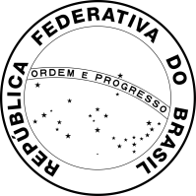
CERTIFICATE OF CONCLUSION OF UNDERGRADUATE DEGREE

We declare for legal purposes, that Nome Completo, son/daughter of Nome do pai and Nome da mãe, born on Data de nascimento, in Belo Horizonte – Minas Gerais, concluded in this University the Undergraduate Studies in Nome do curso recognized by Portaria/MEC n. 919 of 27/12/2018, and received the title of Bachelor on Data de conclusão do curso.

Belo Horizonte, Data de emissão da declaração.

THIS CERTIFICATE SUBSTITUTES THE DIPLOMA WHILE IT IS IN THE REGISTER PROCESS. THE DIPLOMA WILL BE AVAILABLE IN 120 DAYS AFTER THE DATE OF THE GRADUATION CEREMONY.
THIS IS A TRANSLATED VERSION OF THE ORIGINAL DOCUMENT (IN PORTUGUESE) AND SHALL BE VALID ONLY IF ACCOMPANIED BY SIGNATURE OF AUTHORIZED PERSONNEL AND STAMP OF PUC MINAS’ OFFICE OF INTERNATIONAL AFFAIRS.

